**JIRA PROJECT REPORT**

**QUARTERLY PROGRESS REPORT**

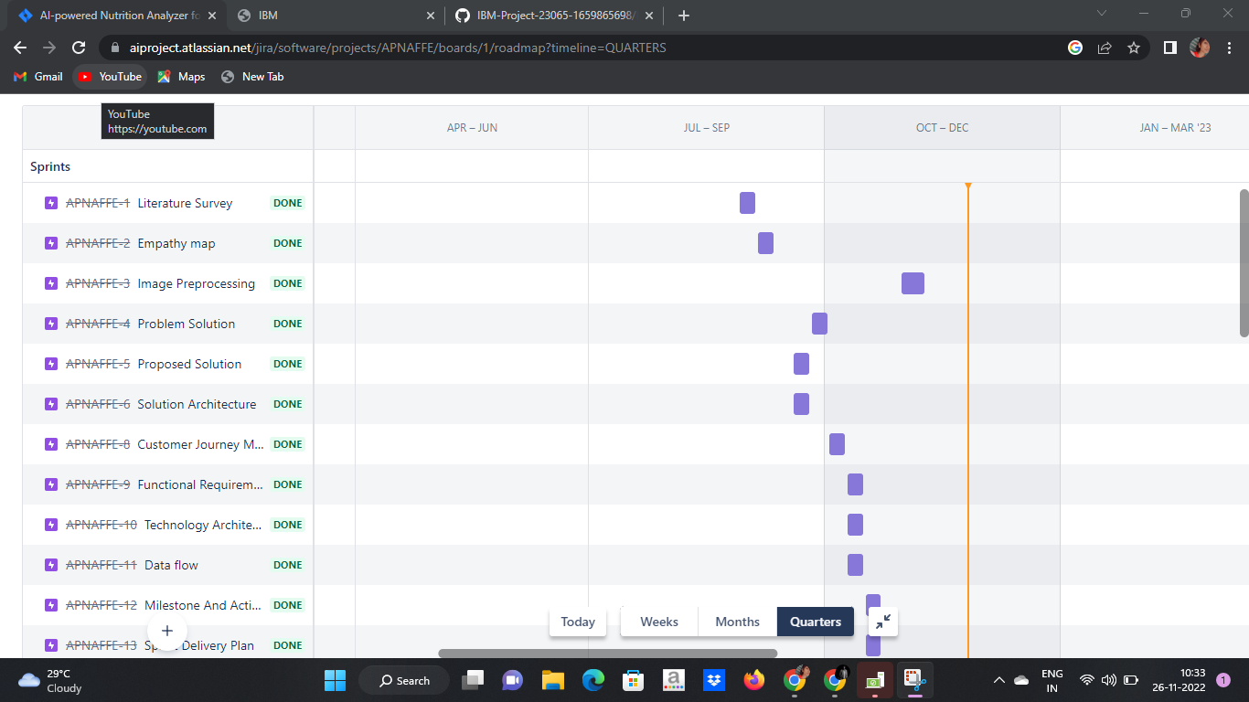

**MONTHLY PROGRESS REPORT**

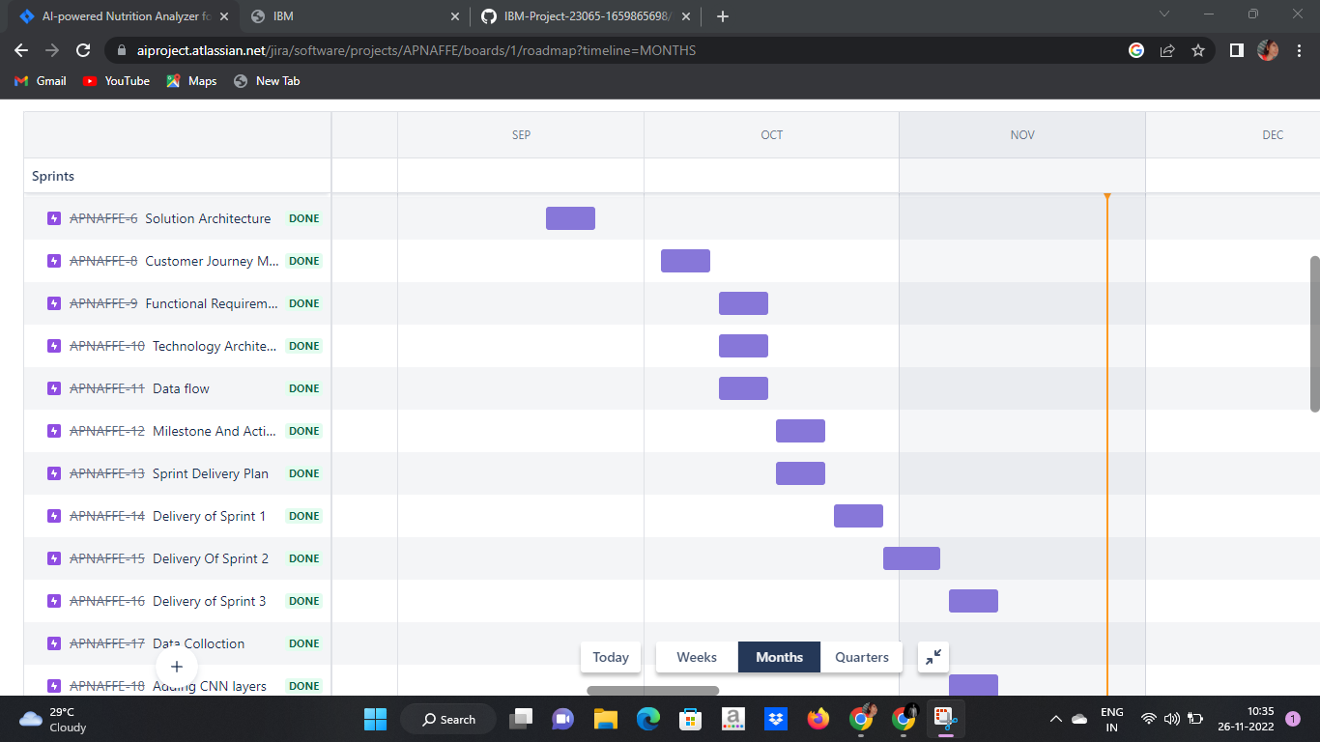

**WEEKLY PROGRESS REPORT**

